**Project Design Phase-II**

**Data Flow Diagram & User Stories**

|  |  |
| --- | --- |
| Date | 28 JUNE 2025 |
| Team ID | LTVIP2025TMID49487 |
| Project Name | House hunt: finding your perfect rental home |
| Maximum Marks | 4 Marks |

**Data Flow Diagrams:**

A Data Flow Diagram (DFD) is a traditional visual representation of the information flows within a system. A neat and clear DFD can depict the right amount of the system requirement graphically. It shows how data enters and leaves the system, what changes the information, and where data is stored.

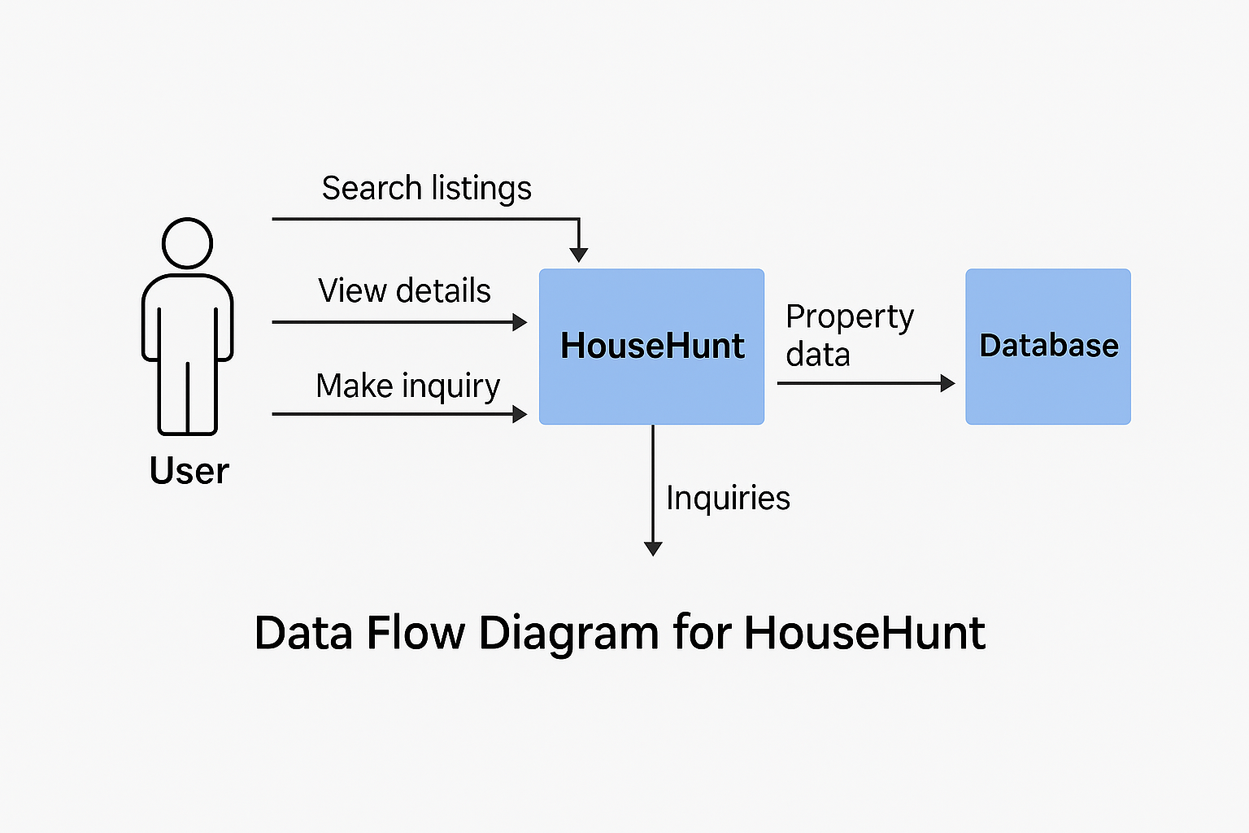

**User Stories**

Use the below template to list all the user stories for the product.

| **User Type** | **Functional Requirement (Epic)** | **User Story Number** | **User Story / Task** | **Acceptance criteria** | **Priority** | **Release** |
| --- | --- | --- | --- | --- | --- | --- |
| Customer (Mobile user) | Registration | USN-1 | As a user, I can register for the application by entering my email, password, and confirming my password. | I can access my account / dashboard | High | Sprint-1 |
| User | Login | USN-2 | As a user, I can log into the application by entering email & password | I can securely log in to my dashboard | High | Sprint-1 |
| User | Dashboard | USN-3 | As a user, I can view my past orders and track current ones | I can see my order history and live status | High | Sprint-2 |
| Customer (Web user) | Voice Ordering | USN-4 | As a user, I can speak to place an order through voice recognition | My voice input is recognized and converted to order | Medium | Sprint-3 |
| Customer Care Executive | Registration | USN-5 | As a web user, I can register and login like mobile users | Registration and login flow is identical to mobile | High | Sprint-4 |
| Administrator | Chatbot Support | USN-6 | As a user, I can ask chatbot for help with orders | Chatbot understands queries and provides help | Medium | Sprint-2 |
| Support Agent | |  | | --- | | Order Management |  |  | | --- | |  | | USN-7 | As a support agent, I can view and update customer orders | Orders are searchable and modifiable | High | Sprint-2 |
| Support Agent | Analytics | USN-8 | As a support agent, I can view reports on order issues | Dashboard shows analytics and failure trends | Medium | Sprint-3 |
| Admin | Product Management | USN-9 | As an admin, I can add/edit/delete products in the system | Product changes reflect in the user interface | High | Sprint-4 |
| Admin | Access Control | USN-10 | As an admin, I can assign roles and control access | Only permitted roles can access specific sections | High | Sprint-3 |